# Team LID - Work Log of Workshop 5 – Travel Experts Web App (ASP.NET)

## Daniel (3/31):

#### Scaffolding

Scaffold TravelExperts DB into Visual Studio, two non-fatal warning appear when doing it. As a result, Class Employee is not generated.



The reason for this is that Employees is an orphan table in database, but since this project is more about customers, packages, and doesn’t involve employee, I will just leave it like this for now.

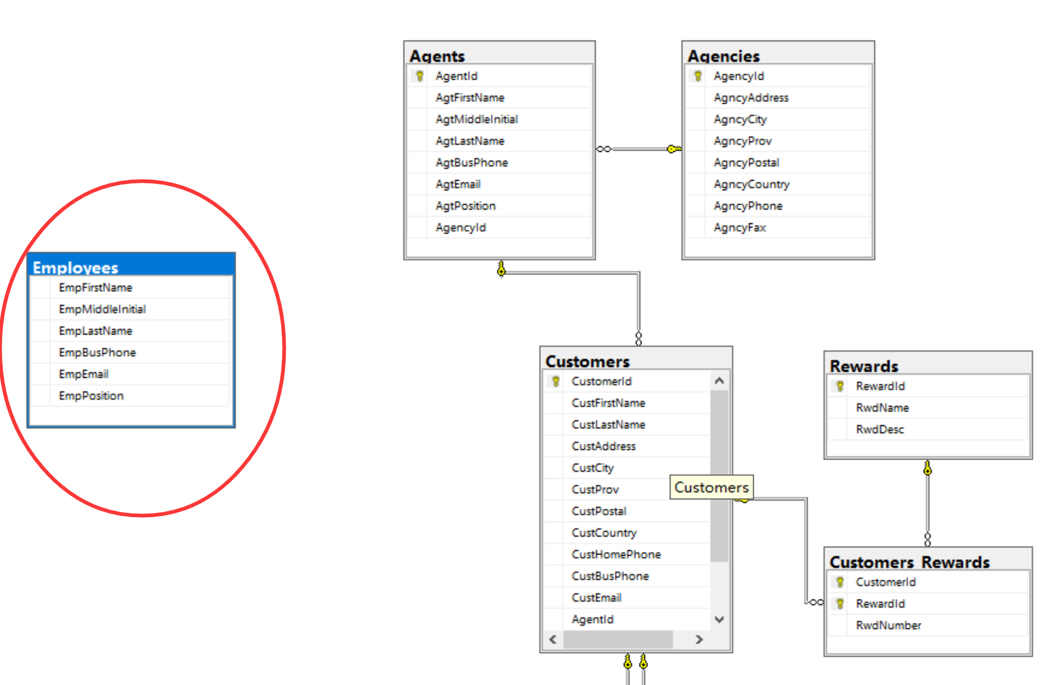

All other entity types were generated successfully.

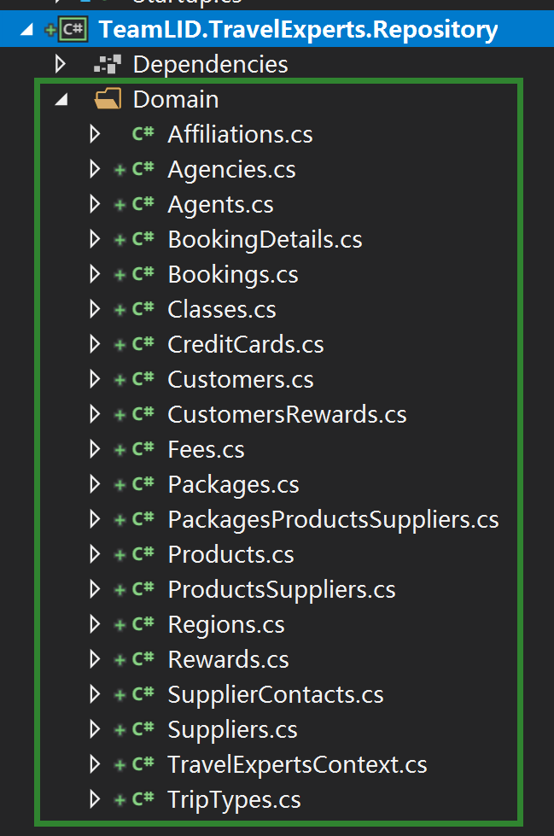

#### Creating Pages (MVC)

Add 3 controllers and views for them: CustomersController, PackagesController, AgentsController

After adding PackagesController and related Views, when try to run, an exception occurred. Need some trouble shooting: may need to configure service for context before using.

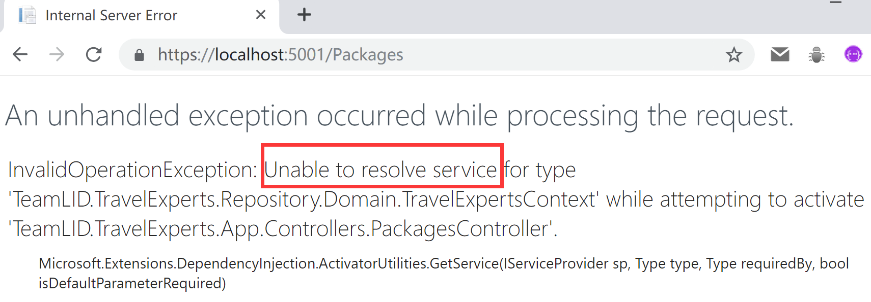

## Daniel (4/1):

#### Trouble Shooting

Add two lines of code in ConfigureServices method to configure the service for context. Now all controllers and views work, but need to be customized to look good.

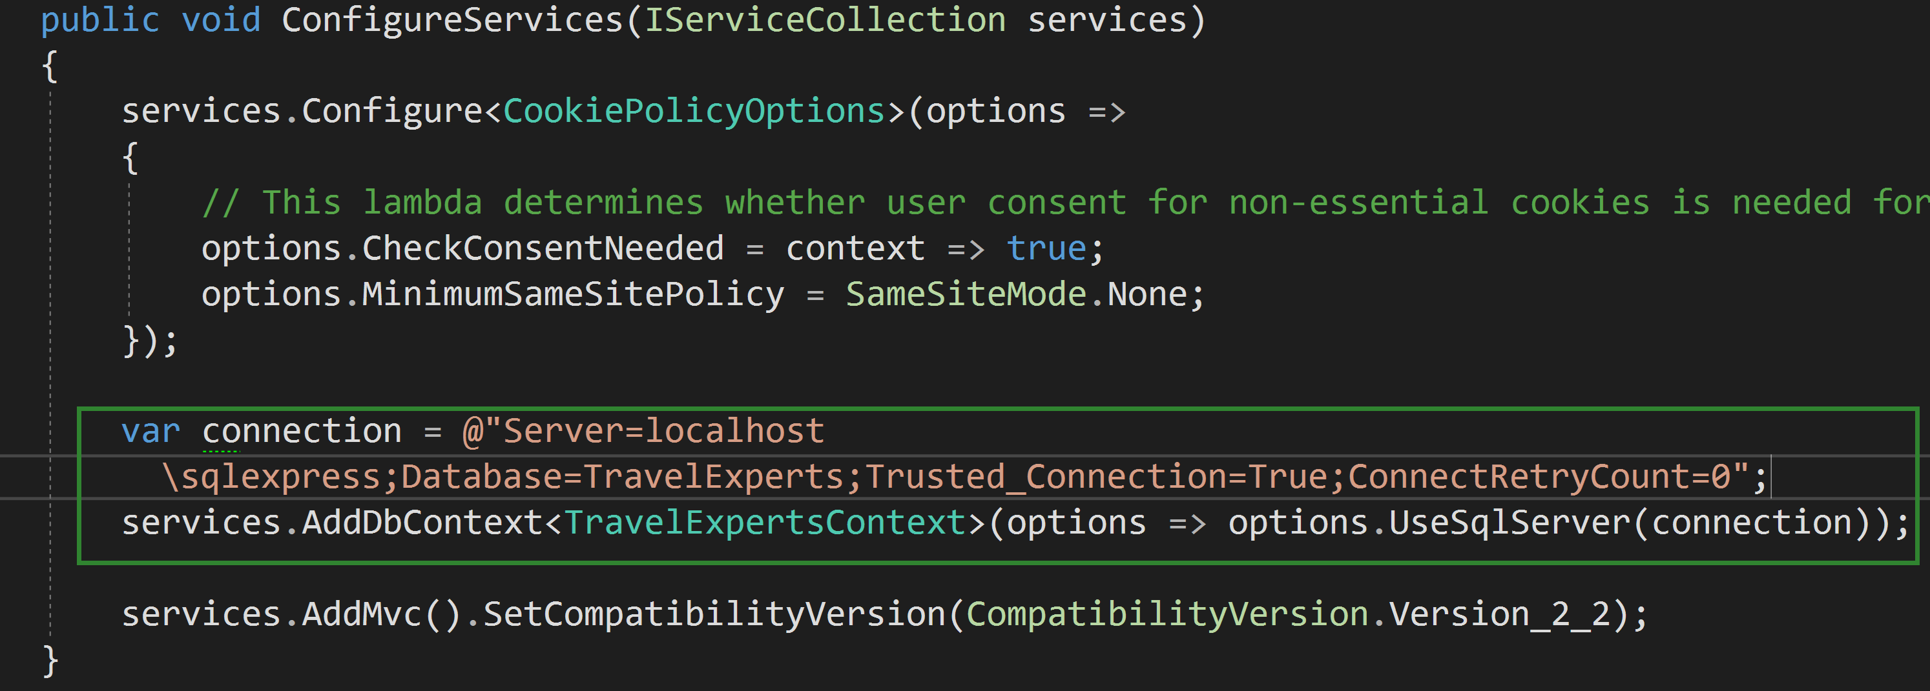

## Daniel (4/2):

#### Building Customer Register Function

Create a class called UserViewModel to store user’s input. This class has all properties (except relational property) from Customers class, with an extra property PasswordConfirm.

